Get Ahead – Animal Management – Introduction to Biology
On your level 2 and level 3 animal management programme you will study a biology module. This unit will cover the principals of animal biology including the formation of cells and tissues, different biological systems, sensory organs and how these features have been adapted to meet the needs of animals living in different environments.
Biology is the study of all living things and a good place to start is to look at individual species, how they are related and how they have evolved. All living things are unique; they have a common name and a scientific name for example…
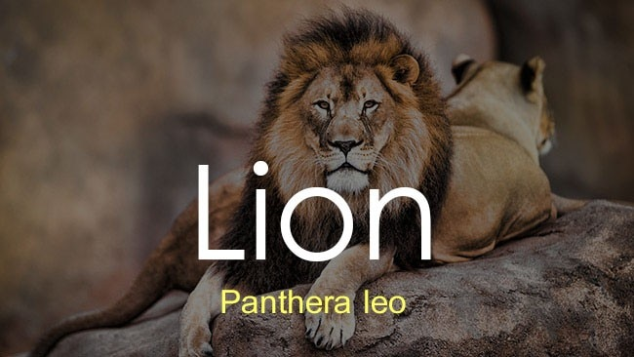
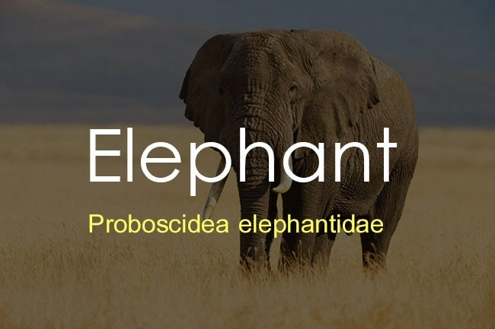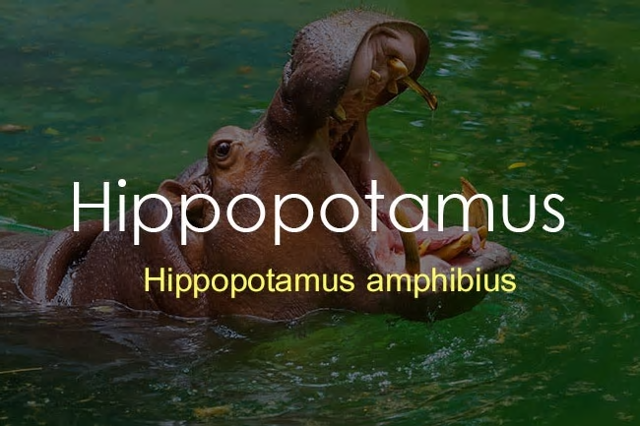
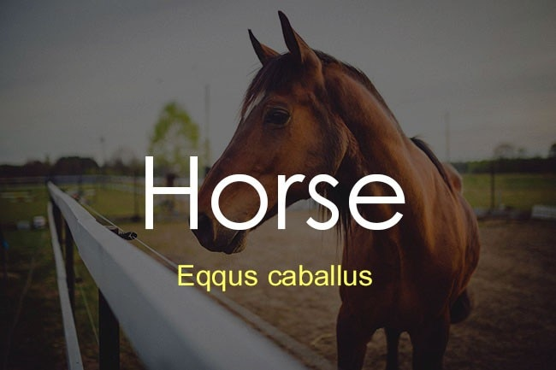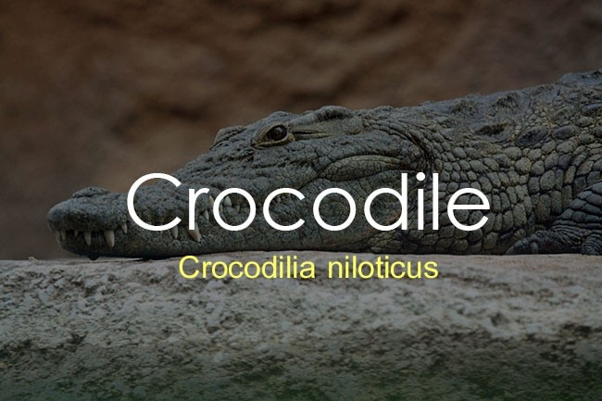
Classification and taxonomy are the science behind grouping and naming living organisms, usually based on their similarities, which could be anatomical, biochemical, behavioural or genetic.
The following audio PowerPoint will introduce you to the basics of classification and taxonomy.
- Insert audio PowerPoint ‘Classification’
- YouTube video = https://www.youtube.com/watch?v=NRVJyUZoQow
- True/False Quiz (below) + answers
Animal Classification True/False Quiz

- Fire salamanders are reptiles
- Koala bears are a type of bear
- Some mammals lay eggs
- Some animals have a skeleton on the outside of their body
- Frogs can ‘breathe’ through their skin
- Animals that only eat meat are called omnivores
- Reptiles are endotherms
- A mushroom is a type of plant
- A cockroach is an invertebrate
- A coral is a plant species that lives in the sea
- A whale is a fish

- The Latin name for a dog is Canis lupus

Animal Classification True/False Quiz - Answers

- Fire salamanders are reptiles = False, they are a type of amphibian.
- Koala bears are a type of bear = False, they are a Marsupial (pouched mammal).
- Some mammals lay eggs = True, monotremes are group of egg laying mammals.
- Some animals have a skeleton on the outside of their body = True, arthropods possess an exoskeleton.
- Frogs can ‘breathe’ through their skin = True, their semi-permeable skin allows gases to pass through.
- Animals that only eat meat are called omnivores = False, carnivores eat primarily meat.
- Reptiles are endotherms = False, ectothermic ‘cold -blooded’
- A mushroom is a type of plant = False, it is a fungi.
- A cockroach is an invertebrate = True, it does not possess a backbone/vertebra.
- A coral is a plant species that lives in the sea = False, it’s an animal
- A whale is a fish = False, it is a mammal.

- The Latin name for a dog is Canis lupus = False, Canis lupus is the Latin name for a Grey wolf.

